ACTIONS IN SCENE2D

Who is it?
- It is a technique used to create the illusion of movement using static images.
Animation
- An animation consists of multiple frames which are shown in a sequence at set intervals
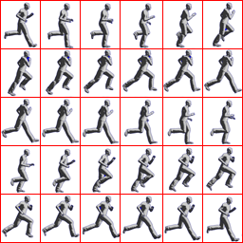

Actions
- Actions are convenient way to get your game's Actors to “do stuff”.
MoveToAction moveAction = new MoveToAction ();
RotateToAction rotateAction = new RotateToAction ();
ScaleToAction scaleAction = new ScaleToAction ();

moveAction.setPosition (300f, 0f);
moveAction.setDuration (5f);
rotateAction.setRotation (90f);
rotateAction.setDuration (5f);
scaleAction.setScale (0.5f);
scaleAction.setDuration (5f);

myActor.addAction (moveAction);
myActor.addAction (rotateAction);
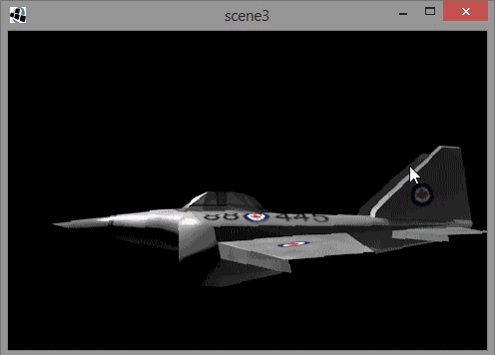
myActor.addAction (scaleAction);

SCENE MANAGEMENT
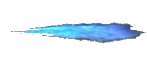
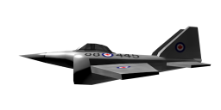

stage = new Stage(Gdx.graphics.getWidth(),Gdx.graphics.getHeight(),true);
final TextureRegion jetTexture = new TextureRegion(new Texture("data/jet.png"));
final TextureRegion flameTexture = new TextureRegion(new Texture("data/flame.png"));

final Actor jet = new Actor(){
public void draw(Batch batch, float alpha){
batch.draw(jetTexture, getX(), getY(), getOriginX(), getOriginY(), getWidth(), getHeight(),
getScaleX(), getScaleY(), getRotation());
}
};
jet.setBounds(jet.getX(), jet.getY(), jetTexture.getRegionWidth(), jetTexture.getRegionHeight());

final Actor flame = new Actor(){
public void draw(Batch batch, float alpha){
batch.draw(flameTexture, getX(), getY(), getOriginX(), getOriginY(), getWidth(), getHeight(),
getScaleX(), getScaleY(), getRotation());
}
};
flame.setBounds(0, 0, flameTexture.getRegionWidth(), flameTexture.getRegionHeight());
flame.setPosition(jet.getWidth()-25, 25);

SCENE MANAGEMENT
private Stage stage;
private Group group;

group = new Group();
group.addActor(jet);
group.addActor(flame);

group.addAction(parallel(moveTo(200,0,5),rotateBy(90,5)));

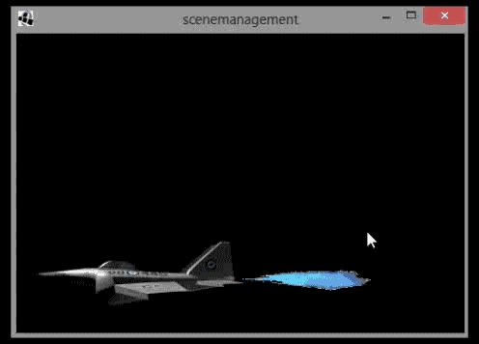
stage.addActor(group);

